NEWS RELEASE
For Immediate Release
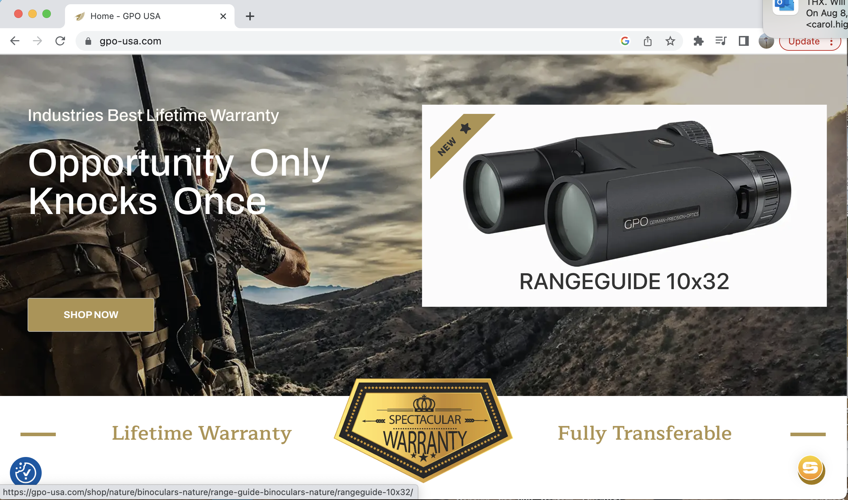
German Precision Optics (GPO) Launches New Website
RICHMOND, Va. (August 14, 2023) — GPO USA is inviting customers to explore its completely redesigned and reshaped website. The new site has been redesigned to offer the ultimate user-friendly experience with improved navigation and functionality while allowing customers to see the full portfolio of optics offered from GPO. It offers many new features as well as an adaptive design regardless of the device being used.

Created with the user experience in mind, the new GPO site is now faster and better organized so users can quickly and easily navigate the site to find the information and products they are looking for. The site now utilizes backend meta data, specs are searchable, and a product comparison function has been added, allowing customers to make an informed purchase decision based on a comparison of product specs which are also searchable.

“We are proud to launch our new website which offers an improved user experience and advanced features. We were determined to match the quality of our products by offering optimized navigation, quality content and power tools to meet the growing needs of our customers,” said Michael Jensen, GPO, USA owner and CEO. “We are confident that this new site will become a valuable resource for anyone looking for premium optics.”

The new site, www.gpo-usa.com is up and running now. Be sure to check it out.

About GPO USA
GPO USA, an American company, was founded on the premise that design, engineering, and quality control can be 100 percent conducted in Germany to its strictest standards, yet products can be assembled at some of the largest production facilities around the world. This unique production process allows GPO to offer the highest quality products with better features at a significantly better price. GPO USA is confident that its products will not only function perfectly but will always exceed its customer expectations. Therefore, GPO USA has created an industry-leading Spectacular Lifetime Warranty™. With outstanding professional service, GPO USA will take care of its products before, during, and after the purchase at no charge—EVER. Founded in 2016, GPO USA is headquartered in Richmond, Va. For more information on GPO USA visit www.gpo-usa.com or call 844-MY BINOS (844-692-4667.)

Editorial Contact:
Karen Lutto
804-539-6699 (cell)
karen@hunteroc.com
HOC Website: www.hunteroc.com

