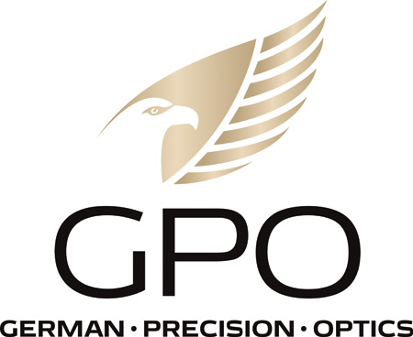
NEWS RELEASE
FOR IMMEDIATE RELEASE

Enter your Youth to Win GPO’S Free 2-Day Youth Turkey Hunt
RICHMOND, Va. (Feb. 21, 2023) —GPO USA, a leading manufacturer and distributor of high-quality sporting optics, has partnered with other industry leaders to award one of seven guided and filmed two-day youth turkey hunts in North Carolina. The hunt will take place on a luxury 11,000 acre private ranch. The youth must be between the ages of 10-15 and must have a valid hunter safety certificate. All meals and lodging will be included for the youth and an adult companion. Each winner will also receive a turkey gun from O.F. Mossberg & Sons, Inc. topped with a GPO SpectraDot® scope and a care package from the others sponsors which include Methodical Media, Edge of the Wild, SPUR Brand, Fox Trot Ammo, HOV Outdoors and Killum Calls.
Entering the contest is easy. Simply go to the GPO Facebook page, https://www.facebook.com/gpousaoptics, like the post and nominate a youth hunter in the comments (if they don’t have social media just comment their name.) Bonus entries can be obtained by sharing the post and tagging GPO. The more you share the more chances you have to win the GPO giveaway. Participants can also enter to win one of the other six hunts from the other sponsors Facebook pages. Each sponsor will be giving away a similar prize package.
“GPO USA has always been a huge proponent of supporting youth hunters, as well as creating new ways to bring young people into hunting, and this is an exciting opportunity to do just that,” said Mike Jensen, GPO USA’s owner and CEO. “In addition to sponsoring one of the contest winners and one adult observer, we’ll be awarding all of the seven youth winners with one of GPO’s cutting-edge SpectraDot® red dot optics that will be mounted on their free Mossberg® shotgun.”
Each participating company will select one winning hunter, for a total of seven youth hunters. There will be two separate hunting groups of four hunters, each accompanied by a caller/cameraman with them. Each hunter will be allowed to harvest one gobbler. Winning hunters and their adult companion are responsible for their own transportation to the hunting location, with all hunt-related expenses paid for once on site for the duration of the hunt. Methodical Media will film and produce the event, which will subsequently be released on Edge of the Wild on Facebook, Instagram, and YouTube.
The contest runs now through February 28, 2023. Winners will be notified via email. The hunt will take place in April 2023.

About GPO USA
GPO USA, an American company, was founded on the premise that design, engineering, and quality control can be 100 percent conducted in Germany to its strictest standards, yet products can be assembled at some of the largest production facilities around the world. This unique production process allows GPO to offer the highest quality products with better features at a significantly better price. GPO USA is confident that its products will not only function perfectly but will always exceed its customer expectations. Therefore, GPO USA has created an industry-leading Spectacular Lifetime Warranty™. With outstanding professional service, GPO USA will take care of its products before, during, and after the purchase at no charge—EVER. Founded in 2016, GPO USA is headquartered in Richmond, Va. For more information on GPO USA visit www.gpo-usa.com or call 844-MY BINOS (844-692-4667.)

Editorial Contact:
Karen Lutto
210-451-9113 (office)
804-539-6699 (cell)
karen@hunteroc.com
HOC Website: www.hunteroc.com

