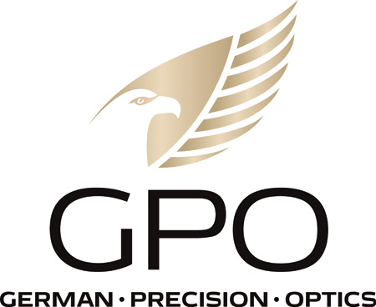
NEWS RELEASE
FOR IMMEDIATE RELEASE
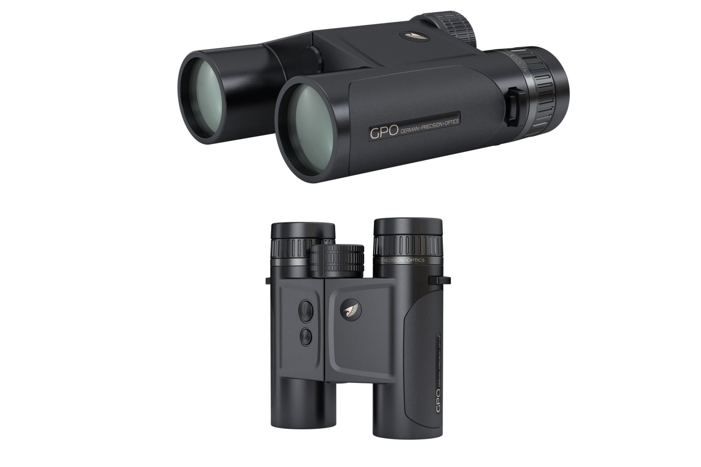
New Video Makes Selecting the Right GPO Rangefinding Binocular
Easier Than Ever

RICHMOND, Va. (May 31, 2023) — Over the past few years GPO has clearly set the industry bar for performance, quality and value in rangefinding binoculars with its lineup of RANGEGUIDE™ rangefinding binoculars. No matter whether you’re a bowhunter or hunt with firearms, a quality laser rangefinder will help you more precisely make the shot no matter the distance. With the advent of high-quality rangefinding binoculars, packing separate units afield is no longer required. With four options to select from, a 10x50, 8x50, 8x32 and 10x32, GPO offers a rangefinding binocular to fit the needs of just about everyone.
“One of the problems our customers have is trying to figure out which rangefinder is best for them ,” said Mike Jensen, GPO, USA’s owner and CEO. “There are so many benefits to each of our RANGEGUIDES it is often hard to determine exactly which is best suited for their specific needs.
“This new video from Backwoods Pursuit on YouTube TV gives a concise look at both the GPO RANGEGUIDE 32 and RANGEGUIDE 5O, how they compare and which might be right for each individuals’ needs. It is certainly worth the watch,” concluded Jensen.
To see the video visit https://www.youtube.com/watch?v=4xd3xluNRE8. Or CLICK HERE.
The RANGEGUIDES, like the GPO riflescopes and binoculars, have been designed by hunters for hunters. The 8x50 and 10x50 RANGEGUIDE units are designed for hunters that want an optic that can transmit maximum light on the cusp of daylight, while the compact 8x32 and 10x32 units will make obsolete the hip-side handheld rangefinder because of the compact size and incredible optics.
Features of all the RANGEGUIDES include an eye-safe Class 1 laser for a lightning fast 0.25-second response time with true-range angle technology that calculates the proper distance to the target after measuring the angle to the target. Scan mode provides three readings per second via its orange OLED display that offers nine adjustable brightness levels and operates with manual or automatic brightness functionality. The RANGEGUIDE even measures ambient temperature in Fahrenheit and Celsius, humidity, and air pressure to help with shot placement on long-range shots. The display provides both the line-of-sight distance and the user’s choice of adjusted distance, angle, or temperature. Coupled with the GPObright™ high-transmission lens coatings, the RANGEGUIDE’s double-HD laminated objective lenses are exceptionally beneficial for transmitting light in the twilight hours. These premium lenses maximize the brightness, sharpness, and resolution of the optical image which is not typical in a rangefinding binocular. The RANGEGUIDE also utilizes GPO’s premium cut-brass-geared focus-wheel system for a tight, consistent turning radius without any center focus wheel free play. The entire body is protected with an armor coating that makes it tough enough to use in any outdoor environment.
The RANGEGUIDE 32mm units carry a MSRP of $1,199.99 and $1,259.99 for the 8x32 and 10x32, respectively, while the 8x50 and 10x50 units carry a MSRP of $1,869.99 and $1,889.99, respectively. All GPO products are backed by the best lifetime warranty and service in the industry, GPO’s exclusive Spectacular Lifetime Warranty™. Included accessories are a neoprene strap, microfiber cleaning cloth, hard case, and battery.
Be sure to check out the new video and find out which GPO RANGEGUIDE is perfect for your hunting needs.

About GPO USA
GPO USA, an American company, was founded on the premise that design, engineering, and quality control can be 100 percent conducted in Germany to its strictest standards, yet products can be assembled at some of the largest production facilities around the world. This unique production process allows GPO to offer the highest quality products with better features at a significantly better price. GPO USA is confident that its products will not only function perfectly but will always exceed its customer expectations. Therefore, GPO USA has created an industry-leading Spectacular Lifetime Warranty™. With outstanding professional service, GPO USA will take care of its products before, during, and after the purchase at no charge—EVER. Founded in 2016, GPO USA is headquartered in Richmond, Va. For more information on GPO USA visit www.gpo-usa.com or call 844-MY BINOS (844-692-4667.)

Editorial Contact:
Karen Lutto
210-451-9113 (office)
804-539-6699 (cell)
karen@hunteroc.com
HOC Website: www.hunteroc.com

# # #

