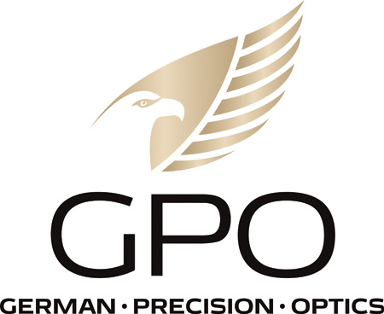
NEWS RELEASE
FOR IMMEDIATE RELEASE

GPO 10x50 RangeGuide Named Best Rangefinding Binocular by
POPULAR MECHANICS Magazine for the Second Time

RICHMOND, Va. (Feb. 1, 2023) — GPO USA’s original 10x50 rangefinding binocular has recently been named the Best Rangefinding Binocular by POPULAR MECHANICS Magazine. This honor was first bestowed upon the product in an article titled “The 7 Best Range Finders for Hunters and Golfers” published October 27, 2021. It was recently honored again as the Best Rangefinding Binocular on January 11, 2023, in “Best 8 Binoculars for Hunting, Birding and other Outdoor Activities.”

Author Justin Park carefully did his research to come to his conclusion about the GPO 10x50 RangeGuide. According to Park, “I’m one of those people. I’ve used the best and the worst binoculars on the market, and I spent time hands-on testing several models during fall big-game hunting seasons in Colorado. I also spoke with optics dealers and shop owners, fellow hunters, and brand representatives to get a full sense of all the different binoculars available. My picks—mostly 10x magnification with objective lens sizes ranging from 32mm to 54mm—are meant to give options for each type of end user, from brands old and new.”

Founded in 1902, POPULAR MECHANICS is one of the oldest magazines in the United States. Since its debut it has remained true to its audience continually publishing articles on home improvement, automobile maintenance and new advancements in technology and science. It has been published since 1958 by Hearst Magazines Corp. Inc.

“It is a real honor to receive this type of recognition, not just one time, but two separate years,” said Mike Jensen, GPO USA owner/CEO. “Our continued efforts to provide our customers with top-quality innovative products has clearly paid off and we are proud of the fact that we continue to receive such prestigious distinctions.”

Since the introduction of the GPO 10x50 RangeGuide, the company has introduced two new compact rangefinding binoculars: an 8x32 RangeGuide and a 10x32 RangeGuide. All three RangeGuides are available at retailers and conveniently online at www.gpo-usa.com. For more information on the RangeGuides Click Here

About GPO USA
GPO USA, an American company, was founded on the premise that design, engineering, and quality control can be 100 percent conducted in Germany to its strictest standards, yet products can be assembled at some of the largest production facilities around the world. This unique production process allows GPO to offer the highest quality products with better features at a significantly better price. GPO USA is confident that its products will not only function perfectly but will always exceed its customer expectations. Therefore, GPO USA has created an industry-leading Spectacular Lifetime Warranty™. With outstanding professional service, GPO USA will take care of its products before, during, and after the purchase at no charge—EVER. Founded in 2016, GPO USA is headquartered in Richmond, Va. For more information on GPO USA visit www.gpo-usa.com or call 844-MY BINOS (844-692-4667.)

Editorial Contact:
Karen Lutto
210-451-9113 (office)
804-539-6699 (cell)
karen@hunteroc.com
HOC Website: www.hunteroc.com

