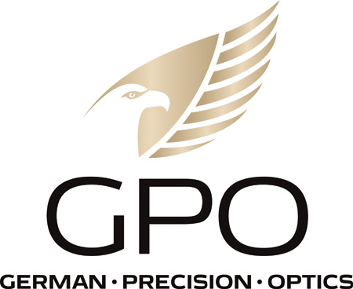
NEWS RELEASE
FOR IMMEDIATE RELEASE

GPO USA To Exhibit at NRA 2023 Annual Meetings & Exhibits

RICHMOND, Va. (April 3, 2023) — GPO USA today announced its presence at the 151st NRA Annual Meetings & Exhibits at the Indiana Convention Center April 14-16, 2023, in Indianapolis, Indiana. The Exhibit Hall is open all three days and will showcase over 14 acres of the latest guns and gear from the most popular companies in the industry. GPO USA will join thousands of exhibitors and attendees at this in-person convention. They will be exhibiting in booth #1712.

GPO USA will be showcasing its new line of SPECTRA riflescopes and GPOTAC tactical riflescopes as well as its award-winning rangefinders and binoculars. The company will be offering exclusive NRA show specials. All NRA attendees are encouraged to stop by booth #1712 for daily specials and giveaways.

“We are proud to exhibit and be a part of the NRA Annual Meetings again this year,” said Mike Jensen, president and CEO. “We are a staunch believer in our second amendment rights and know that the NRA fights for these rights for us, our industry and all Americans. We are glad to be here in support of them.”

The NRA offers free admission for all NRA members and their immediate family (spouse & children under 18 years old.) Don’t miss this opportunity to see all the latest guns and gear and join fellow Second Amendment patriots for a freedom filled weekend. And be sure to stop by the GPO USA booth #1712 for the latest in state-of-the-art optics.

About GPO USA
GPO USA, an American company, was founded on the premise that design, engineering, and quality control can be 100 percent conducted in Germany to its strictest standards, yet products can be assembled at some of the largest production facilities around the world. This unique production process allows GPO to offer the highest quality products with better features at a significantly better price. GPO USA is confident that its products will not only function perfectly but will always exceed its customer expectations. Therefore, GPO USA has created an industry-leading Spectacular Lifetime Warranty™. With outstanding professional service, GPO USA will take care of its products before, during, and after the purchase at no charge—EVER. Founded in 2016, GPO USA is headquartered in Richmond, Va. For more information on GPO USA visit www.gpo-usa.com or call 844-MY BINOS (844-692-4667.)

*Media that would like to schedule an appointment to see the new products from GPO, please contact Kimi Herndon at kimi@hunteroc.com to get on the schedule.

Editorial Contact:
Karen Lutto
210-451-9113 (office)
804-539-6699 (cell)
karen@hunteroc.com
HOC Website: www.hunteroc.com

# # #

