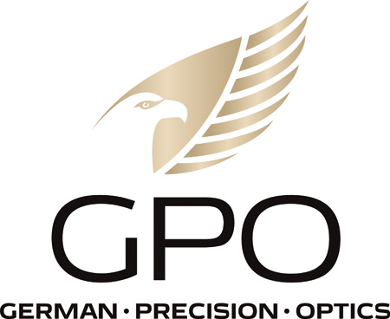
NEWS RELEASE
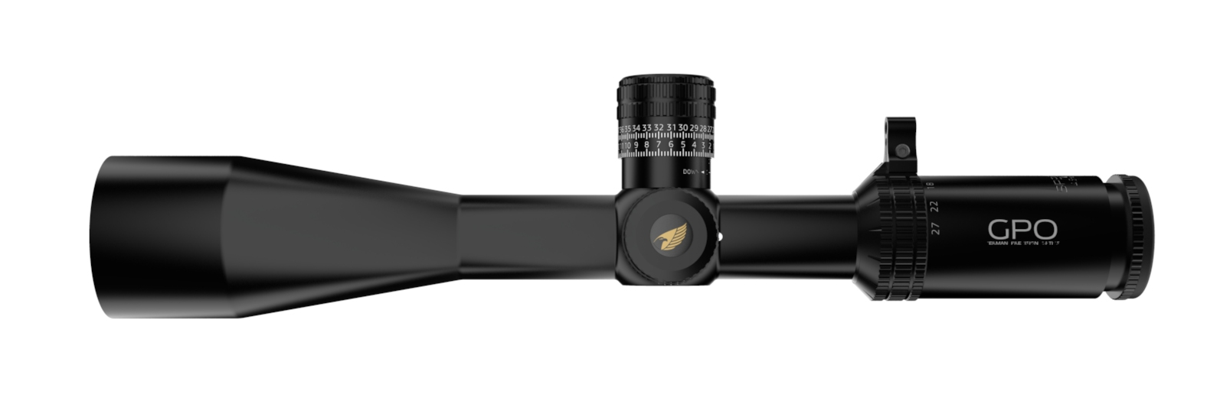
GPO’s SPECTRA™ 6X 4.5-27x50i SFP: The Ultimate Long-Range Hunting Riflescope
RICHMOND, Va. (March 20, 2023) — Designed as the ultimate long-range, high-performance riflescope, the German Precision Optics (GPO) SPECTRA 6X 4.5-27x50i SFP has been built to give premium performance for those who hunt game in environments where shooting at extended ranges is often required.
“The SPECTRA™ 6X 4.5-27x50i second focal plane is our ultimate long-range hunting scope,” said Michael Jensen, GPO, USA owner and CEO. “It has every bell and whistle the most discerning shooter and hunter desires in a second focal plane design. And while the quality and features meet or exceed that of more expensive brands, it’s offered at a very affordable price.” With a second focal plane riflescope, the reticle is placed behind the magnification lenses on the erector tube assembly, and the reticle remains the same size as the scope’s variable power is turned up or down, making a fine subtension ballistic reticle with an illuminated center micro-dot for longer shots.
The SPECTRA™ 4.5-27x50i SFP’s large 50mm objective lens system transmits a great deal of light to your eye, while the 4.5-27X variable power range gives you ample magnification for both close and the longest-range shots. Throw in the proprietary iCONTROL™ microdot illumination and shot placement on dark targets will make you a believer. This scope comes standard with DoubleHD™ objective lens technology with fully-multi coated lenses, iCONTROL illumination, PASSIONtrac™ ZERO-STOP-LOCK turrets to assist your shooting scenario. The turrets provide +/- 30 inches/MOA of adjustment range at 100 yards. The new SPECTRA 6X 4.5-27x50i SFP features:
* GPObright: A proprietary coating process that maximizes light transmission through each surface of an optical element. As light hits an optical surface, normal uncoated high-performance glass can reflect up to 5 percent of that light, redirecting this light so it does not transmit through the optical system. However, when these high-performance lenses are vacuum coated with GPObright lens coatings, up to 99.7 percent of the available light passes through each optical surface. Furthermore, when every surface of the entire optical system is properly coated, total light transmission can reach up to more than 92 percent, making the optical image of a GPO binocular or riflescope “bright,” even in the lowest light conditions.
* Double HD Objective Lens Technology: This is the final product, created when multiple extra-low dispersion lenses are chemically laminated to make a single, multilayer high-performance optical lens. Laminating multiple lenses minimizes light reflection on the surface of multiple lenses, creates enhanced resolution and color contrast images, and minimizes chromatic aberrations. This benefit is clearly visible with all GPO products supporting this feature. This high-performance process is routinely found in the photographic market and with the highest-quality photographic lens manufacturers but has now transitioned into premium sporting optics.
* iControl Illumination: This assures users always have a live battery by automatically powering down the illumination when the electronic module has been stationary for more than 3 hours, and alerts users when the battery has only 15 percent remaining battery life.
This scope is crafted from a one-piece 30mm anodized, nitrogen-filled aluminum main tube that has zero-stop locking turrets, precise ¼ MOA click adjustments, CCW click rotation, removable magnification throw lever, 3rd turret parallax adjustment, fast focus ocular, and multiple rotation engraving. It will be available in the spring of 2023 for a suggested retail price of $1249.99.
All GPO products are backed by the best lifetime warranty and service in the industry, GPO’s exclusive Spectacular Lifetime Warranty™. The SPECTRA 4.5-27x50i SFP comes with a cleaning cloth, see-through flip cap ocular and objective lens scope covers, and CR2032 battery. More information is available at www.gpo-usa.com or by calling 844-MY BINOS (844-692-4667.)
About GPO USA
GPO USA, an American company, was founded on the premise that design, engineering, and quality control can be 100 percent conducted in Germany to its strictest standards, yet products can be assembled at some of the largest production facilities around the world. This unique production process allows GPO to offer the highest quality products with better features at a significantly better price. GPO USA is confident that its products will not only function perfectly but will always exceed its customer expectations. Therefore, GPO USA has created an industry-leading Spectacular Lifetime Warranty™. With outstanding professional service, GPO USA will take care of its products before, during, and after the purchase at no charge—EVER. Founded in 2016, GPO USA is headquartered in Richmond, Va. For more information on GPO USA visit www.gpo-usa.com or call 844-MY BINOS (844-692-4667.)

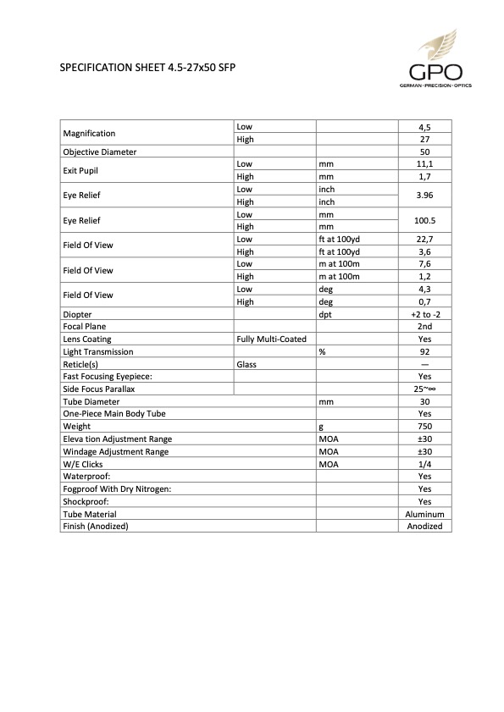
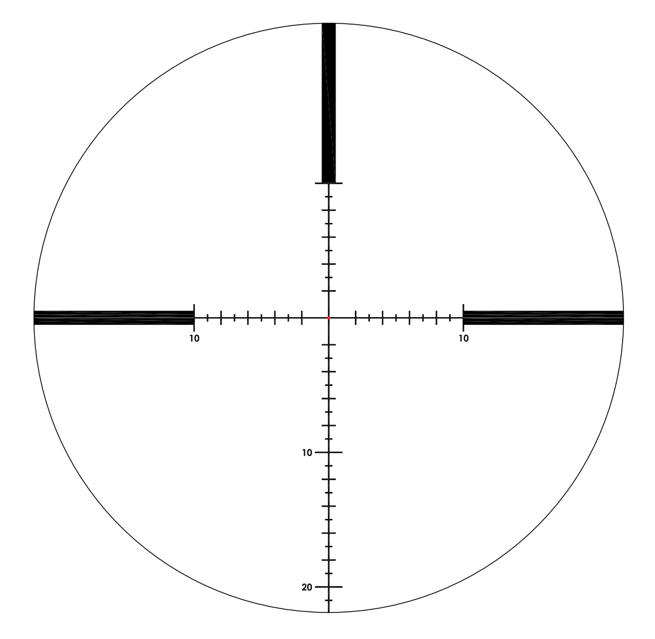

Editorial Contact:
Karen Lutto
804-539-6699 (cell)
karen@hunteroc.com
HOC Website: www.hunteroc.com

